**Client name**

To write reports in Crystal Reports you will first need to establish a connection between your local copy of Crystal Reports and your WebLink hosted database. This is a simple process that involves only a few steps and once completed your Crystal Reports will remember the connection information as long as you have the application open. Also, after creating and saving (or modifying) a report the file will remember your connection information and you will only need to re-enter your password to make changes again. To establish a connection, please follow these steps:

1. Open your copy of Crystal Reports.
2. Go to File 🡺 New 🡺 and choose a create new report option such as “Blank Report”.
3. Expand the “Create New Connection” node and double-click on the “OLE DB (ADO)” option (highlighted in Figure 1-1):

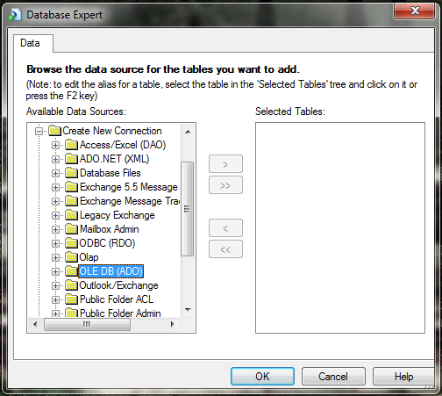

Figure 1-1: OLE DB (ADO)

1. Choose “Microsoft OLE DB Provider for SQL Server” (highlighted here in Figure 1-2):

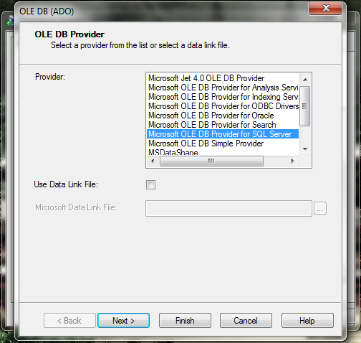

1. Click “Next >” to continue to the Connection Information screen.
2. Enter your unique connection information as follows:

|  |  |
| --- | --- |
| Field | Value |
| Server: |  |
| User ID: |  |
| Password: |  |
| Database: |  |

* 1. Do not check the “Integrated Security” checkbox.

1. Click the “Finish” button

Crystal Reports will now return to the Database Expert screen. You can now add or remove any database tables or views you will need in your report. The tables can be added by following these steps:

1. Underneath your database name (It will display as: TESTALCOC).
2. Expand the dbo section.
3. Expand the Tables section (highlighted below in Figure 1-3).
4. Click on the table(s) you would like to add.
5. Add a single table with the > button.
   1. To add multiple tables at once use the >> button.
6. Click the OK button to accept these tables.

Views, which are pre-determined fields created by WebLink to assist in report creation, can be used to create reports. The views are the recommended option as they will generally have all the information for a report already grouped together for you to use rather than having to build it yourself. To add a view to your report, please follow these steps:

1. Underneath your database name (It will display as: HuntsvilleMadisonALCOC).
2. Expand the dbo section.
3. Expand the Views section.
4. Click on the view you would like to add.
   1. WebLink only recommends adding a single view to a report.
5. Add the view with the > button.

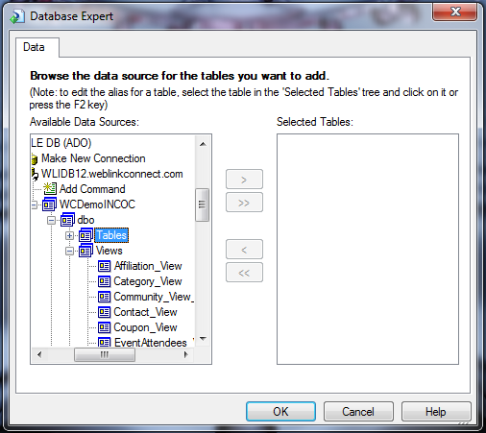

Figure 1-3: Adding Tables

You are now ready to begin building your report!